Department of Forest and Wildlife Ecology

120 Russell Laboratories, 1630 Linden Drive

Madison WI 53706-1598 USA

July 11th 2019

Dear Emilio

Please find enclosed our new manuscript “Half a century of forest cover change along the Latvia-Russian border captured by Corona and Landsat Images”. This manuscript represents a major advance in studies of land use change. It is the first, to our knowledge, that demonstrates how to classify land cover automatically for a large area based on 1960s Corona imagery. The 2.5-m Corona data capture land cover two decades prior to the first 30-m Landsat data, and that allowed us to look at half a century of forest cover change for a large region.

Analyzing forest cover and forest change based on the Corona data led to very surprising results. Increases in forest cover due to agricultural abandonment *after* the collapse of the Soviet Union in 1991 are well documented, and post-soviet abandonment is one of the major land change processes globally in the last thirty years. However, our new results show that abandonment *prior* to the collapse, i.e., under Soviet Rule was even higher! I have worked on land use change in Eastern Europe for many years, and never expected this.

We suggest that our manuscript makes a novel contribution because there have been no broad-scale studies mapping land cover automatically from Corona data before. In 2018, RSE published a prior paper from our team (Nita et al., 2018) that introduced new methods how to *georectify Corona imagery* efficiently for large areas, but forest cover was hand-digitized in that study. The manuscript we are submitting now presents the logical next step and shows a) how to *classify Corona imagery* for large areas automatically, and b) how to combine it with Landsat data for long-term change analyses.

We also suggest that our manuscript fits well within the scope of *Remote Sensing of Environment*, and is ‘worthy’ of publication in the top journal in the field, because we present an important advance in remote sensing methods related to the Corona data, and their application for land use science. Just last month, I had the opportunity to visit the Corona archive at EROS, which is mindboggling in size. The available Corona data already covers the entire globe, and an additional 14,000 rolls of film have been recently declassified and are being added to the archive right now. The Corona data are thus a tremendous resource to understand land use in the 1960s, but they have been vastly underused because of the lack of methods to analyze the data efficiently for large areas. That is the knowledge gap that our new manuscript fills.

The work in our new manuscript has not been published or accepted for publication elsewhere, and is not under consideration for publication in another journal. The submission of this version of our manuscript to *Remote Sensing of Environment* has been approved by all co-authors. We are looking forward to your response and the comments of your reviewers.

Best,

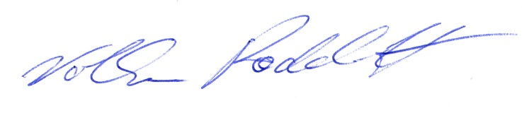

Volker Radeloff

Professor

[radeloff@wisc.edu](mailto:radeloff@wisc.edu)

608-263-4349