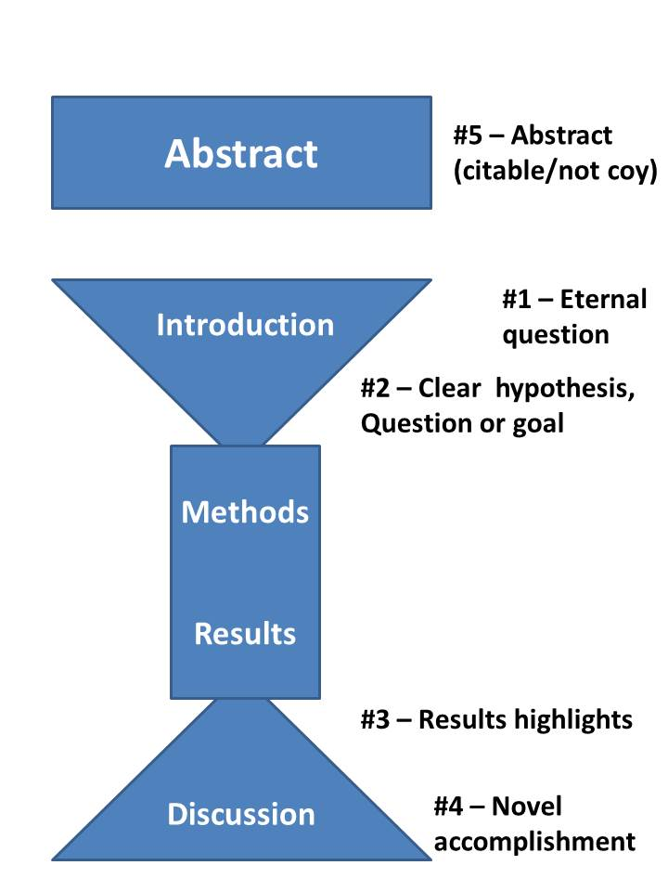

Thoughts on each of the 5 pivotal paragraphs

1. **First paragraph of the introduction** – you should use this paragraph to embed and contextualize your work in the context of a large classic, timeless, eternal question. What drives species richness. Or controls abundance or distribution. Or gives the best management outcome. Or explains why species are invasive. Or controls carbon flux. You of course are not going to fully answer this question. Indeed no one person, and probably even no generation of scientists will fully answer this question, but ask a really big question. You can then use this big question setup to spend the rest of the introduction summarizing past attempts to answer this question, and show how they have all failed to address the key issue you are about to address.
2. **Last paragraph of the introduction** – This is probably the 2nd most important paragraph after the abstract. It MUST give a clear concise statement of what your core hypothesis, question or goal is. So while #1 is very general and you won’t/can’t answer it, #2 is totally specific to your paper and it should be answered before the paper is done (at least in your system). Depending on the field and your work, this may be phrased as a hypothesis, a question or a goal. But it should be crystal clear what your paper is about. Aside from readers getting really cranky if you haven’t clearly stated your question by the time they get to the end of the introduction, this is a great set up to start telling them how you answered it in the next section (methods). But do not start introducing (even in a summary fashion) the methods – here. This is a very common mistake I see. State the question independent of methods. Then describe the methods in the next section.
3. • **First paragraph of the discussion** – You have just taken the reader through the weeds of every analysis you have done, every comparison to a null model, every check on alternative models and buried them in p-values or AIC values (or preferably effect sizes, r2 and RMSE numbers). You now must pull up out of the weeds and tell them what the IMPORTANT results are, the ones you want them to remember. You probably told them 6 or 7 things, but some of those were necessary side shows. Take them back to the main attractions. (And if you want them to remember 5 different things you either haven’t thought it through enough or you need to split up your paper). This is also where you start shedding the statistical rigor you needed in the results section and pulling back to emphasizing the biological interpretation. This paragraph often looks as simple as one sentence each for: recap of biological result #1, recap biological result #2, recap biological result #3, and together these suggest X. Boom! the reader is now back in the big picture and you have set up the whole rest of the discussion where you can acknowledge limitations on why #1-#3 aren’t perfect for proving X but can argue that they’re pretty good, and you can put X back into the context of the literature again.
4. • **Last paragraph of the discussion** – This paragraph is the most variable (the other 4 paragraphs really should be used for only exactly the one purpose I mentioned). But in my experience this paragraph ties your main claim (from #3) which responds to your goal/question (from #2) back to your eternal question (#1) and makes a novelty statement about how you have made progress towards improving our knowledge of the eternal question. In this way it serves as a nice summary of the whole paper.
5. **Abstract** – There are two schools of thought on the abstract: write it first to outline your paper, or write it last to summarize what you wrote. I fall in the latter camp, but it doesn’t matter for the purposes here. What should be in the abstract is the same regardless of when you write it. The most common mistake I see in abstracts is to devote 2/3 of the abstract to setting up the question and then lamely ends on a sentence or two of methods and some mealy-mouthed phrase about “various results are shown”. Its almost like people start writing until they fill up 200 words (or whatever the limit is) and then they stop. But my best guess is that half the people who open your paper will only look at the abstract. So you have to say the most important things in there. Overall an abstract should exactly parallel the paper (the whole paper). One or two sentences on the question (e.g. one that is general matching paragraph #1 and one that is specific matching #2). Probably just one or two sentences summarizing methods and giving key facts (anybody who reads your abstract should know what types of organisms, where studied, for how long studied and how big the sample size). The main results MUST be in the abstract. Don’t bury your results. As I said this is probably the most common mistake – if you don’t have exciting results in your abstract, only a handful of devotees are going to read further! And abstracts should be about biological results and conclusions, not statistical. And your punchy conclusion and novelty statement should be the last sentence. In short getting paragraphs #2, #3, and #4 into your abstract are the most important goals, but generally writing a 5-8 sentence version of your whole paper is a good approach. Just make sure it is clear what you accomplished. Think about somebody who is only going to read your abstract; you want them to walk away knowing what your main conclusion is, so don’t be coy and tease your results and conclusion – punch them hard in your abstract.

https://dynamicecology.wordpress.com/2016/02/24/the-5-pivotal-paragraphs-in-a-paper/