Thesis Title

By

Your Name

A dissertation completed in partial fulfillment of

the requirements for the degree of

Doctor of Philosophy

(Forestry*)

*or whatever your PhD is in!

at the

UNIVERSITY OF WISCONSIN – MADISON

YEAR

Date of final oral examination: MM/DD/YY

This dissertation is approved by the following committee:

Name, position title, department

…

# Abstract

UW Graduate School guidelines

<http://grad.wisc.edu/education/completedegree/etd.pdf>

**Acknowledgements**

**Table of Contents**

Abstract i

Introductory Chapter (Heading 1) 1

Heading 2 1

Heading3 1

Chapter Title 2

Abstract 2

Introduction 2

Subheading 2

Methods 2

Subheading 2

Results 2

Subheading 2

Discussion 2

Conclusion 2

References 2

**List of Figures**

Figure 1. Koala's are cute! 2

You must right click on the figure, table, or appendix and use the ‘insert caption’ function in order for your captions to be recognized by Word and inserted in to the List of Figures/Tables/Appendices. The default text may be blue and the wrong font, but you can easily modify this like you would any other text. Table and Appendix captions go above while Figure captions go below (this is also a preset in Word so there shouldn’t be confusion).

To insert reference to a table or figure go to the Insert tab and click cross-reference. From here you can choose your own options including if you want the reference hyperlinked.

Example: Figure 1.

**List of Tables**

Table 1. Green Bay Packers 2012 roster (partial) 3

**List of Appendices**

Appendix A. Really important stuff that didn’t fit in my chapter. 5

# Introductory Chapter (Heading 1)

## Heading 2

### Heading3

These headings have been formatted and are available under the Home tab. If you select your heading text and click the appropriate heading tab, it will update in the table of contents when you select the table of contents, right click and select update.

# Chapter Title

# Abstract

Words, words, words.

## Introduction

Words, words, words.

### Subheading

Words, words, words.

## Methods

### Subheading

Words, words, words.

## Results

Words, words, words.

### Subheading

Words, words, words.

## Discussion

## Conclusion

## References

Table 1. Green Bay Packers 2012 roster (partial)

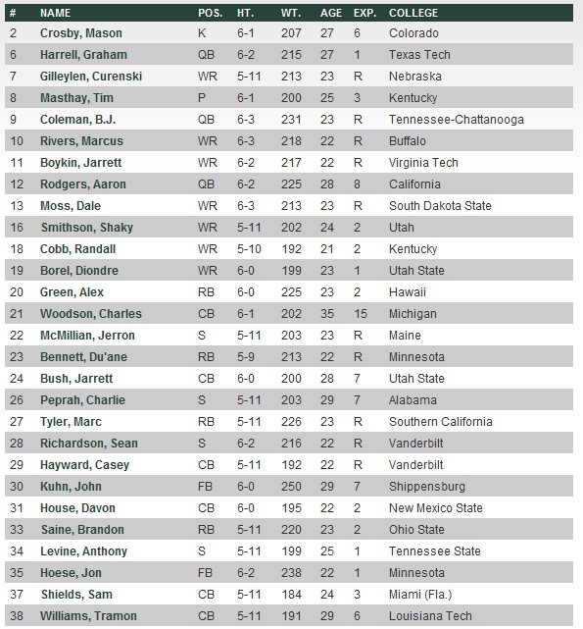

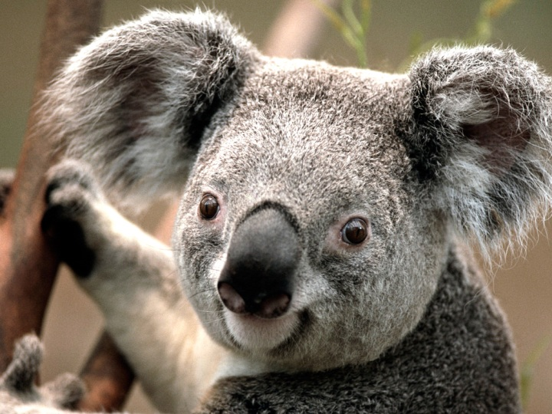

Figure 1. Koalas are cute!

Appendix . Really important stuff that didn’t fit in my chapter.

