THE DEVELOPMENT OF MADISON AS AN INTERESTING PLACE
by

Iam A. Student

A thesis submitted in partial fulfillment of the requirements for the degree of

Master of Science (Geography)

at the

UNIVERSITY OF WISCONSIN-MADISON 2022

Abstract
UW Madison Master’s Requirements:
https://grad.wisc.edu/current-students/masters-guide/#what-you-need-to-do

Acknowledgements

Table of Contents
Abstract i
Introductory Chapter (Heading 1) 1
Heading 2 1
Heading3 1
Chapter Title 2
Abstract 2
Introduction 2
Subheading 2
Methods 2
Subheading 2
Results 2
Subheading 2
Discussion 2
Conclusion 2
References 2

List of Figures

Figure 1. Koala's are cute! 2

You must right click on the figure, table, or appendix and use the ‘insert caption’ function in order for your captions to be recognized by Word and inserted in to the List of Figures/Tables/Appendices. The default text may be blue and the wrong font, but you can easily modify this like you would any other text. Table and Appendix captions go above while Figure captions go below (this is also a preset in Word so there shouldn’t be confusion).

To insert reference to a table or figure go to the Insert tab and click cross-reference. From here you can choose your own options including if you want the reference hyperlinked.
Example: Figure 1.

List of Tables

Table 1. Green Bay Packers 2012 roster (partial) 3

List of Appendices

Appendix A. Really important stuff that didn’t fit in my chapter. 5

Introduction

Significance

References

These headings have been formatted and are available under the Home tab. If you select your heading text and click the appropriate heading tab, it will update in the table of contents when you select the table of contents, right click and select update.

Chapter Title

Abstract
Words, words, words.

Introduction
Words, words, words.

Subheading
Words, words, words.

Methods

Subheading
Words, words, words.

Results
Words, words, words.

Subheading
Words, words, words.

Discussion

Acknowledgements

Bibiography

Table 1. Green Bay Packers 2012 roster (partial)
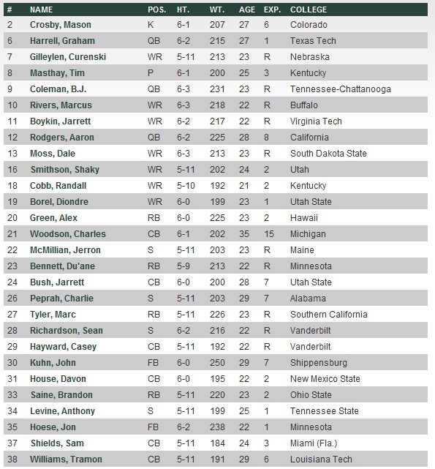
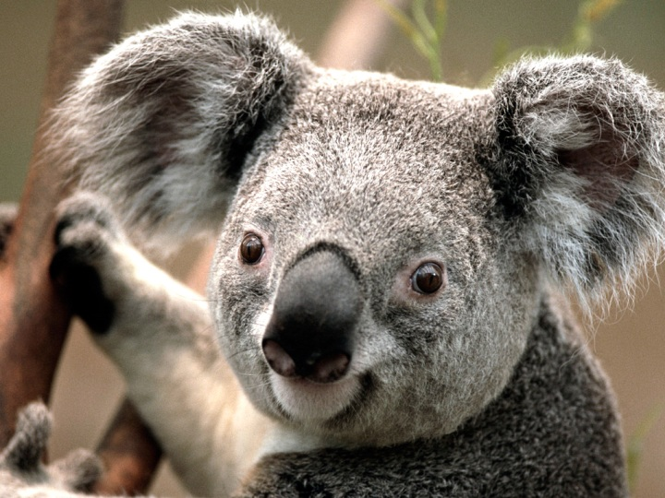
Figure 1. Koalas are cute!

Appendix A. Really important stuff that didn’t fit in my chapter.

