Vegetation loss in grasslands in the Caucasus 2002-2018
Metadata for visualization:
Data title: Annual vegetation loss rates (short-term and decadal degradation together).
Legend title: vegetation loss rate
color ramp, values form 0.0 to -0.085 with 0 set to noData.
color preferences something like in the example below:
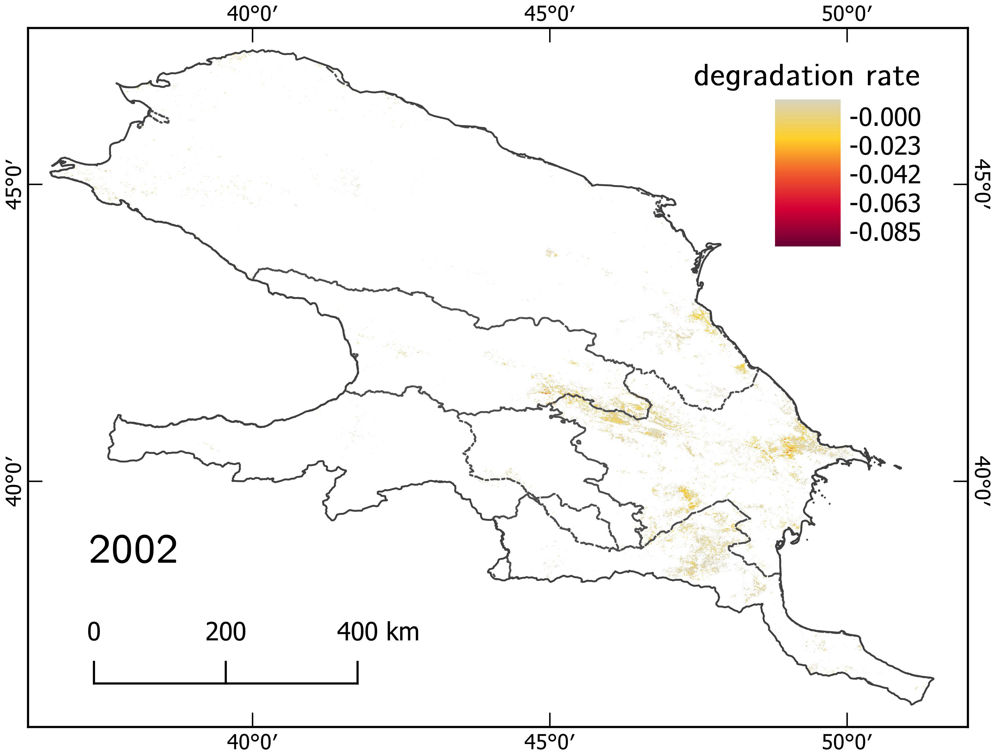
I am not fixated on this particular color scheme, but I guess it would be good to keep it consistent with the paper. I copied a qgis color ramp definition into the main folder.

Description:
Annual green vegetation loss rate, presented together for short-term (3-9 years) and decadal (> 10 years) degradation. The change rate is derived as a pixel-specific magnitude (i.e., change in green vegetation Cumulative Endmember Fraction (CEF) between the first and the last year of each trend segment) divided by the length (in years) of the respective trend segment. CEF is scaled between 0 and 1.
For a full description of the Cumulative Endmember Fraction (CEF) and the methodology used to produce the datasets, please see the related publication listed below.
Related publications:
Lewińska K.E., Hostert P., Buchner J., Bleyhl B., Radeloff V.C., 2020, Short-term vegetation loss versus decadal degradation of grasslands in the Caucasus based on Cumulative Endmember Fractions, Remote Sensing of Environment, 248 https://doi.org/10.1016/j.rse.2020.111969

Downloads:
Vegetation loss 2002-2018
File: \\gaia\gaiadata\helmers\Caucasus_Kasia\ MODSI_ANNUAL_gv_Decrease_YearlyRate8_Normalized_2002-2018.tif

